

FACULTY OF INFORMATION AND COMMUNICATION TECHNOLOGY

DCOMP204 – WEB DESIGN 1

Title : Individual Assignment 2
Issue Date : Week 4
Due Date : Week 10
Lecturer/Examiner : Mr. Ahmadu Kamara
Name of Student/s : Ibrahim S Saccoh
Student ID No. : 905005312
Class : BIT 1105F
Year/Semester : 2/1

Academic Honesty Policy Statement

I/We, hereby attest those contents of this attachment are my own work. Referenced works, articles, art, programs, papers or parts thereof are acknowledged at the end of this paper. This includes data excerpted from CD-ROMs, the Internet, other private networks, and other people’s disk of the computer system.

Student’s Signature: Date:
LECTURER’S COMMMENTS/GRADE:

for office use only upon receive
Remark

DATE:
TIME:
RECEIVER’S NAME:

HOME PAGE SCREENSHOT
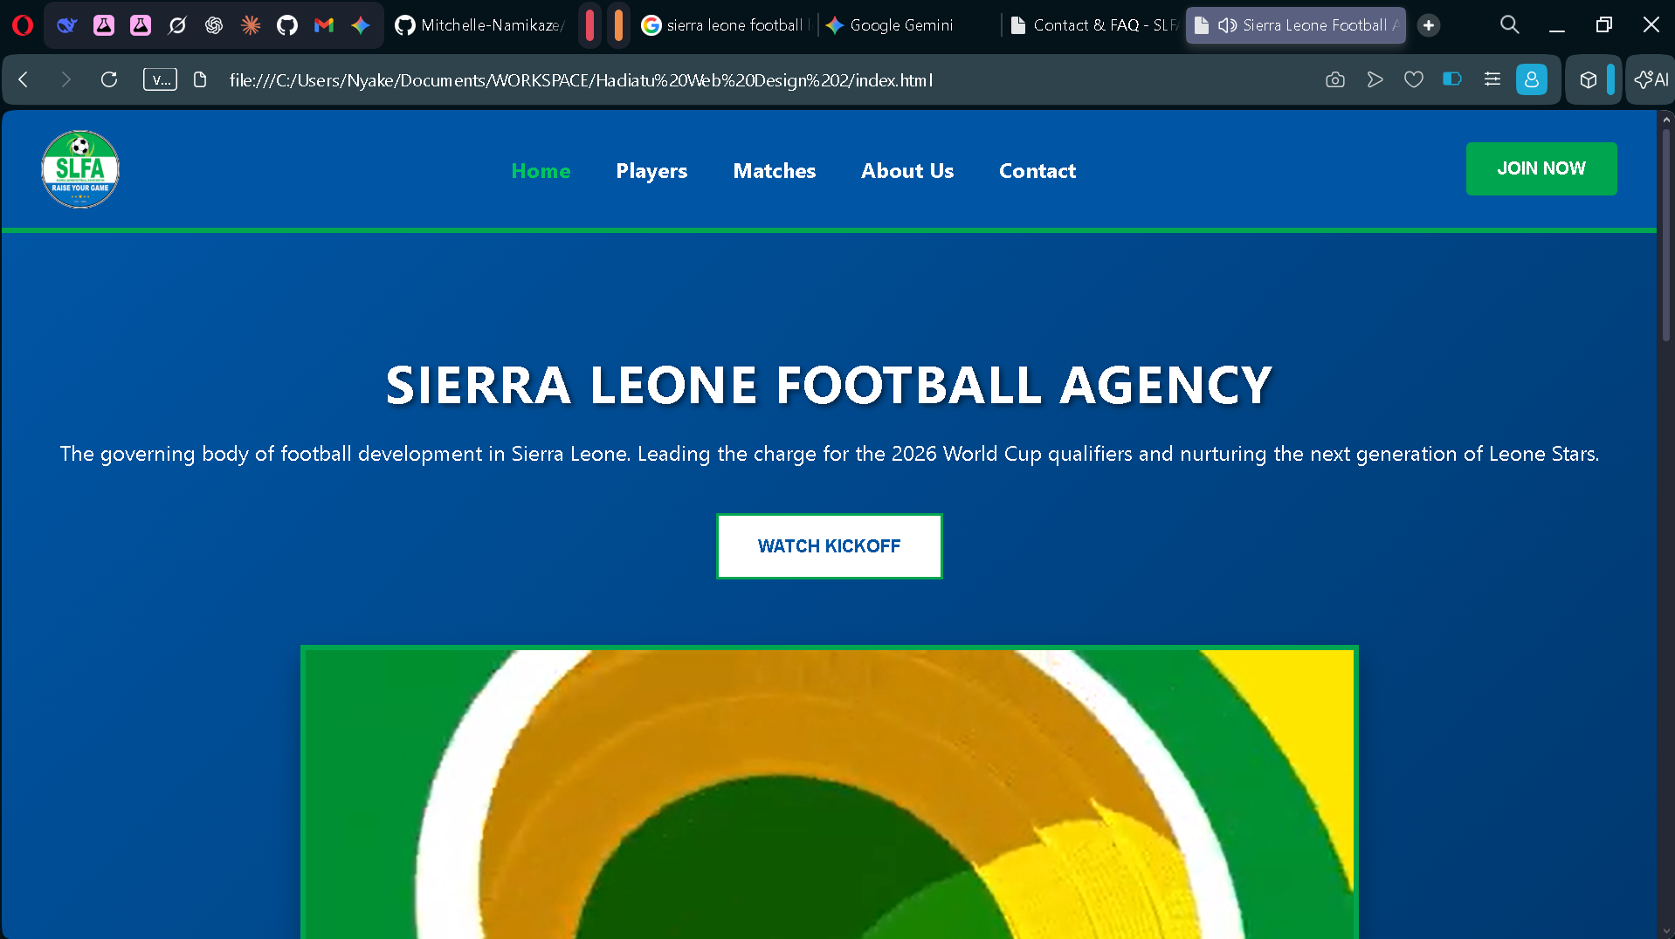

PLAYERS PAGE SCREENSHOT
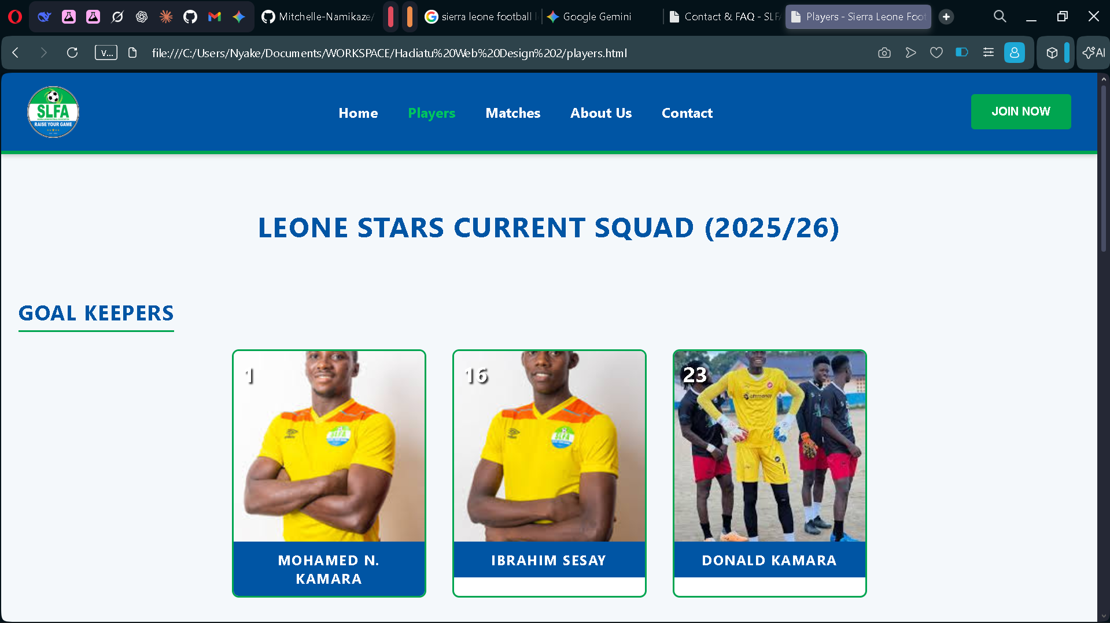

MATCHES PAGE SCREENSHOT
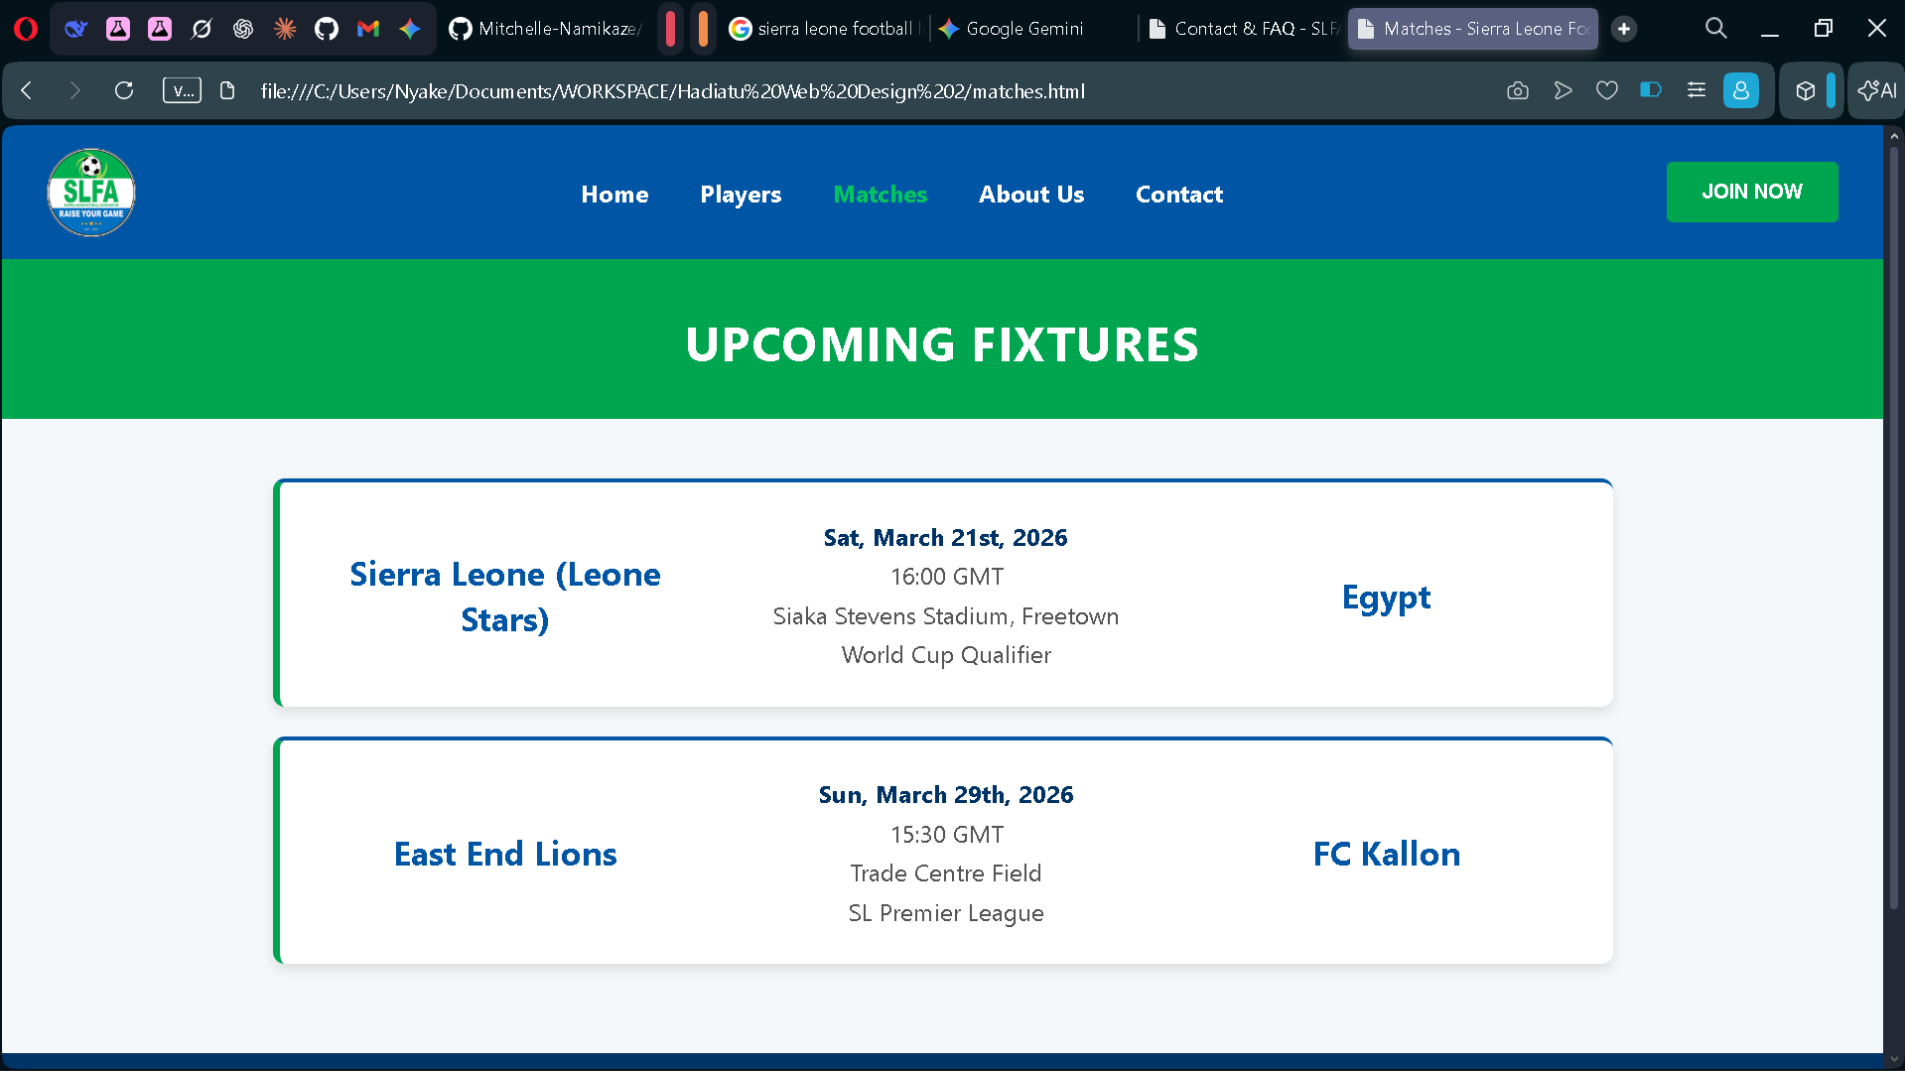

ABOUT US PAGE SCREENSHOT
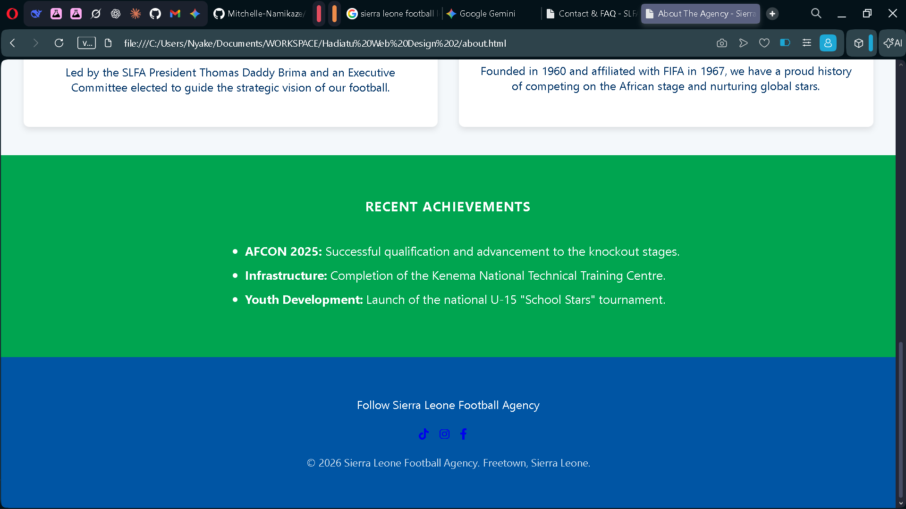

CONTACT US PAGE SCREENSHOT
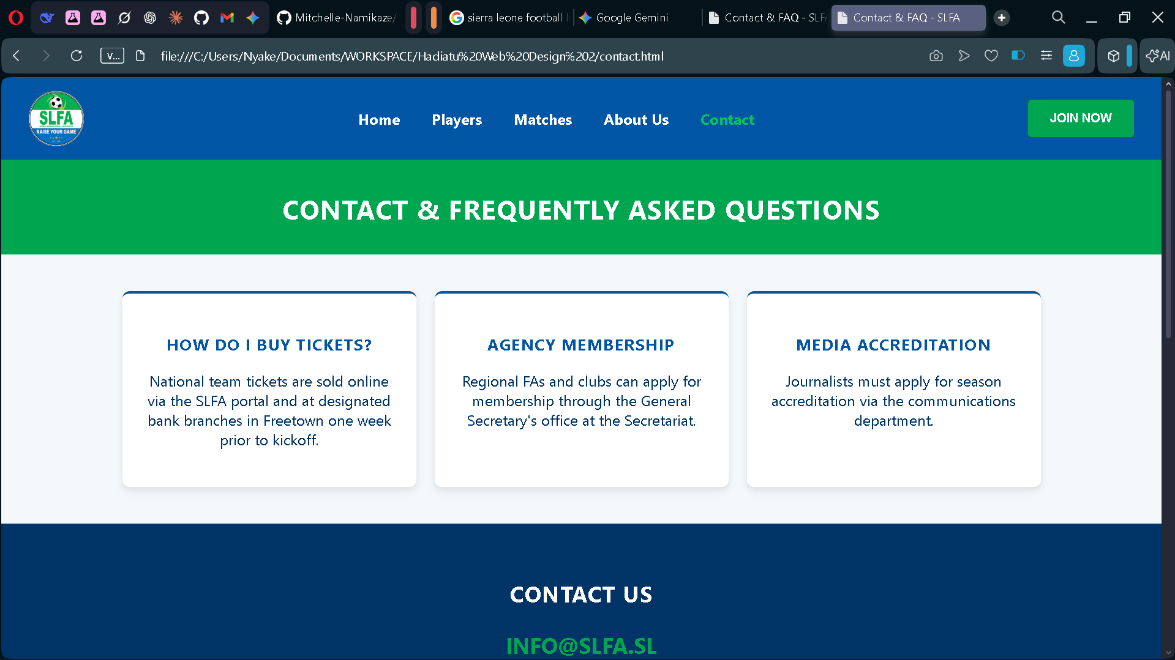

HOME PAGE CODE
<!DOCTYPE html>
<html lang="en">
<head>
<meta charset="UTF-8">
<meta name="viewport" content="width=device-width, initial-scale=1.0">
<title>Sierra Leone Football Agency | Home</title>
<link rel="stylesheet" href="style.css">
</head>
<body>
<nav class="top-nav">
<img src="slfa-logo.png" alt="SLFA Logo" class="nav-logo">

<div class="nav-links">
<a href="index.html" class="active">Home</a>
<a href="players.html">Players</a>
<a href="matches.html">Matches</a>
<a href="about.html">About Us</a>
<a href="contact.html">Contact</a>
</div>
<button class="join-btn">JOIN NOW</button>
</nav>

<header class="hero">
<h1>Sierra Leone Football Agency</h1>
<p>The governing body of football development in Sierra Leone. Leading the charge for the 2026 World Cup qualifiers and nurturing the next generation of Leone Stars.</p>
<button class="cta-btn">WATCH KICKOFF</button>
<div class="video-container">
<video controls poster="leone-stars-poster.jpg">
<source src="nvs.mp4" type="video/mp4">
Your browser does not support the video tag.
</video>
</div>
</header>

<section class="news section-pad">
<h2>LATEST NEWS</h2>
<p>Stay updated with the 2025/26 Premier League and National Team developments.</p>
<div class="news-list">
<div class="news-item">
<img src="news1.jpg" alt="Stadium construction">
<p>SLFA announces upgrades to regional stadiums for 2026 season.</p>
</div>
<div class="news-item">
<img src="news2.jpg" alt="Leone Stars Training">
<p>Leone Stars intensify training camp ahead of crucial qualifier.</p>
</div>
<div class="news-item">
<img src="news3.jpg" alt="Youth League">
<p>U-17 National Youth League finals set for next month in Makeni.</p>
</div>
</div>
<a href="#" class="learn-more">Read All News ></a>
</section>

<section class="highlights section-pad">
<h2>SEASON HIGHLIGHTS</h2>
<div class="carousel">
<button class="prev-btn">❮</button>
<div class="cards">
<article class="card">
<img src="h1.jpg" alt="Bo Rangers">
<h3>Champions Again</h3>
<p>Bo Rangers celebrate another Premier League title defense.</p>
</article>
<article class="card">
<img src="h2.jpg" alt="Derby Day">
<h3>Freetown Derby</h3>
<p>Intense action between East End Lions and Mighty Blackpool.</p>
</article>
<article class="card">
<img src="h3.jpg" alt="Women's Football">
<h3>Queens of WAFU</h3>
<p>Sierra Queens lift the regional trophy in historic win.</p>
</article>
</div>
<button class="next-btn">❯</button>
</div>
</section>

<section class="partners section-pad">
<h3>OFFICIAL PARTNERS</h3>
<div class="sponsor-logos">
<span>AFRICEL</span> <span>LEONE ROCK METAL</span> <span>SIERRA RUFILE</span>
<button class="partner-btn">BECOME A SPONSOR</button>
</div>
</section>

<footer class="social-footer">
<p>Follow Sierra Leone Football Agency</p>
<div class="social-icons">
<div class="icon-placeholder">TT</div>
<div class="icon-placeholder">IG</div>
<div class="icon-placeholder">FB</div>
<div class="icon-placeholder">X</div>
</div>
<p class="copyright">© 2026 Sierra Leone Football Agency. Freetown.</p>
</footer>
</body>
</html>

